Week-1 EDA Report
Data Visualization Associate Internship


Submitted By:
Name | ID
Muhammad Tazeem Sajid | tazeemsajid22@gmail.com
Raj Vekariya | vekariyaraj33@gmail.com
Pari Nagdev | parirani1535@gmail.com
Ronit Ghai | ronitghai@hotmail.com
Muhammad Alam | malam62032@gmail.com
Siddhi Kulkarni | siddhikulkarni713@gmail.com

Excelerate – Powered by Saint Louis University (SLU)
Internship Program

Introduction

Motivation
In order to drive data-informed decisions for improving learner engagement, opportunity performance, and platform effectiveness, it is essential to understand the structure and quality of platform data. This analysis explores various datasets related to users, opportunities, cohorts, marketing performance, and learner participation. By uncovering patterns, gaps, and inconsistencies, we set the foundation for transforming this data into actionable insights through cleaning and visualization.

Report Overview
The primary goal of this internship is to analyze learning-related datasets using exploratory data analysis (EDA) techniques. We focus on three core datasets that capture user engagement, program opportunities, and profile metadata. These insights will support downstream processes like data transformation, dashboard creation, and predictive analytics.
The datasets provided are part of a broader learning and engagement ecosystem. This EDA project focuses on six main datasets, each offering unique insights into the behavior and structure of the platform:
User Data – Demographics and profile-level details.
Opportunity Data – Descriptions and metadata for learning programs.
Cohort Data – Cohort-based tracking of programs and timelines.
Marketing Data – Campaign engagement and performance metrics.
Learner Opportunity Data – Learner interactions and enrollment tracking.
Cognito Data – User authentication and profile metadata.

Objectives
- Understand the schema and inter-relationships of the datasets
- Explore and summarize each dataset individually
- Identify and handle missing and duplicate values
- Detect outliers and data anomalies
- Generate visualizations to reveal patterns
- Compile insights to guide future data processing and dashboarding

Dataset Overview & Data Dictionary

DataSet OverView

Dataset Name | Description | Row Count | Column Count
User Data | Contains user profiles, sign-up info, education, and location | 129,259 | 5
Opportunity Data | Information about learning opportunities and programs | 187 | 5
Cohort Data | Tracks cohorts, their associated opportunities, and timeframes | 639 | 5
Marketing Data | Includes campaign details like impressions, engagement, and cost | 148 | 13
Learner Opportunity Data | Maps learners to opportunities and records application metadata | 113,602 | 6
Cognito Data | Profile authentication metadata, including gender, city, and timestamps | 13,318 | 5

Data Dictionary
    - User Data Dataset

Column | Type | Non-Null Count
learner-id | Object | 129,259
country | Object | 126,984
degree | Object | 76,566
institution | Object | 76,358
major | Object | 76,562

Summarize the Data
Since all fields are categorical, we’ll analyze:
- Unique value counts
- Most frequent entries
Let’s check the top countries and degree types next.

Top 10 Countries Represented

Country | Count
India | 33,868
Nigeria | 30,696
Pakistan | 14,112
Kenya | 8,246
United States | 7,064
Ghana | 6,874
Philippines | 6,039
Egypt | 5,301
South Africa | 4,587
Bangladesh | 3,525

Top 7 Degree Types
Degree Type | Count
Graduate Student | 31,806
Undergraduate Student | 30,709
Not in Education | 6,319
High School Student | 4,109
Other Professional | 2,997
Teacher/Educator | 562
Parent of Student | 64

Identify Missing and Duplicate Values
We'll now compute:
- Missing values per column
- Duplicate records
Missing and Duplicate Data Summary
Column | Missing Count
country | 2,275
degree | 52,693
institution | 52,901
major | 52,697

Duplicate Rows: 0 found
Over 40% of the records are missing values in degree, institution, and major.

Spot Outliers and Anomalies
Again, since all columns are categorical, we’ll check
- Rare degree entries
- Potentially misspelled or invalid countries
All degree types are valid and expected:
- Undergraduate Student
- Graduate Student
- High School Student
- Other Professional
- Not in Education
- Teacher/Educator
- Parent of Student
No anomalies detected in degree entries.
Next, let’s visualize the data distribution and missing values.

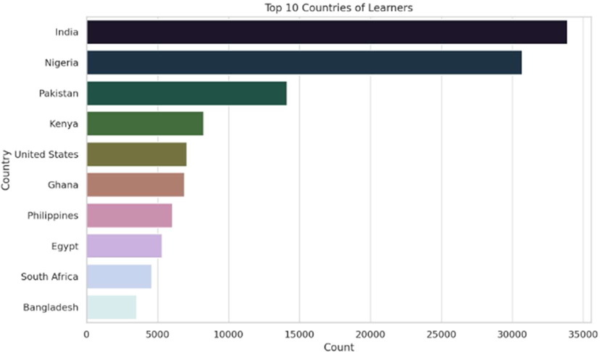

Next, we’ll visualize missing data to better understand the structure of incompleteness.

The missing data heatmap clearly shows:
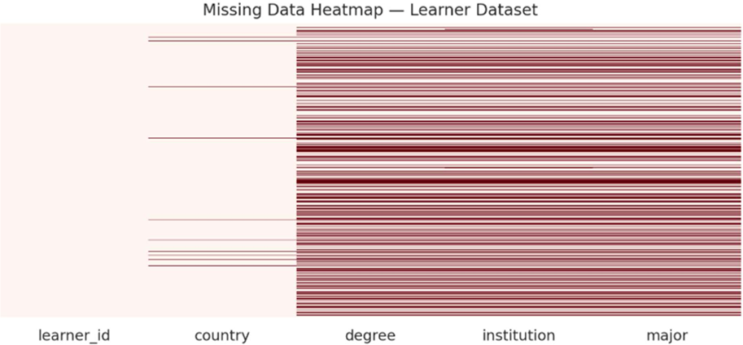
- Large blocks of missing values in the degree, institution, and major columns.
- Missingness appears systematic rather than random.
Final EDA Summary — Learner Dataset Data Overview:
- 129,259 records, 5 categorical columns.
- No duplicate entries.
Summary Statistics:
- Most learners are from India, Nigeria, and Pakistan.
- Top degrees: Graduate and Undergraduate Students. Data Quality:
- High missing rates:
- Degree, institution, major: ~40% missing.
- Country: ~2% missing.
- All categories are valid.
Visual Insights:
- Strong geographic concentration.
- No anomalies in degree types.
- Missing data is prevalent and clustered.

    - Opportunity Data
Column | Data Type | Non-Null Count
opportunity_id | Object | 187
opportunity name | Object | 187
category | Object | 187
opportunity code | Object | 187
tracking questions | Object | 187

Summarize the Data
Since all fields are categorical, we’ll analyze:
- Unique value counts
- Most frequent entries
Top 6 Opportunity Categories
Category | Count
Internship | 43
Event | 41
Competition | 41
Career | 23
Course | 18
Masterclass | 11

Identify Missing and Duplicate Values
We'll now compute:
- Missing values per column
- Duplicate records
Missing and Duplicate Data Summary
- Missing Values: None
- Duplicate Rows: None

Spot Outliers and Anomalies
- No numeric columns to test for outliers.
- All categories are valid.
Next, let’s visualize the data distribution and missing values.
Opportunity Category Distribution
- Bar chart showing frequency of opportunity types.
- Internship, Event, and Competition dominate the dataset.

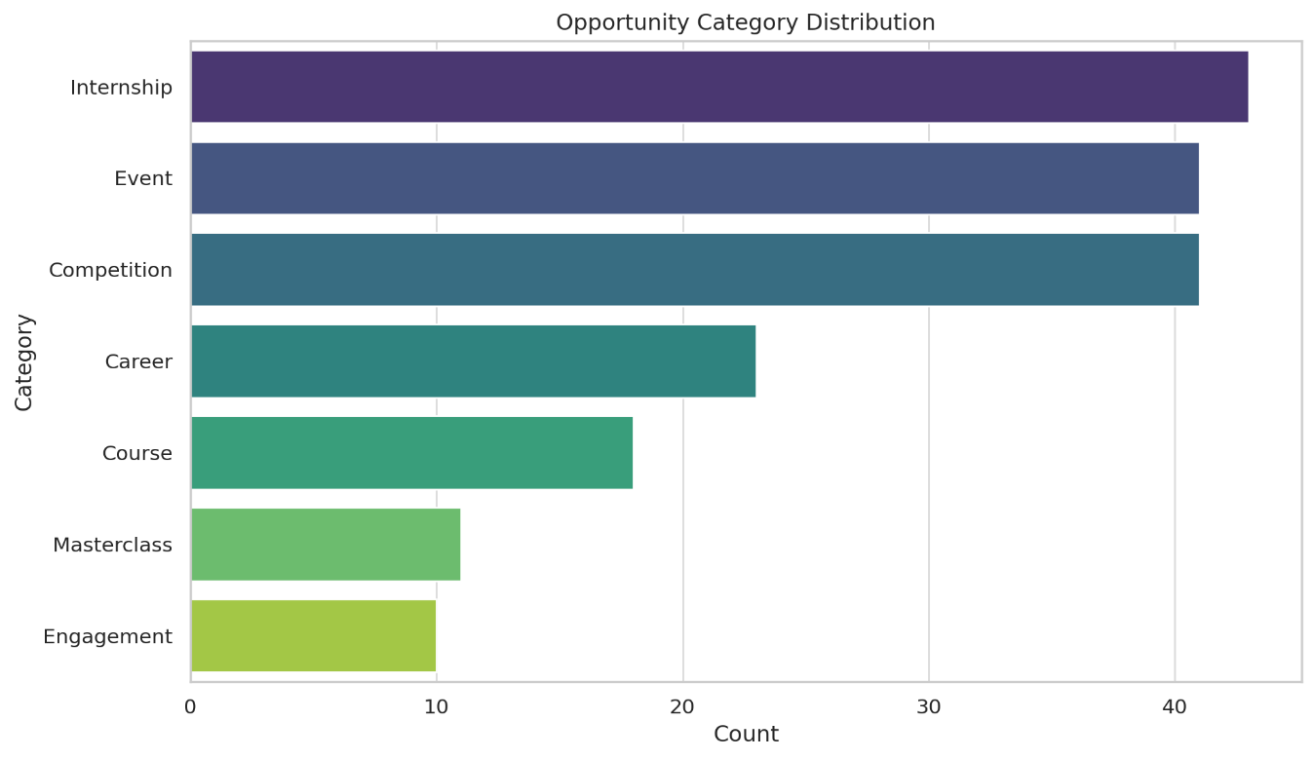

Top Opportunity Names
- Highlights the most common or repeated opportunity titles.
- Useful for identifying popular or duplicated program offerings.
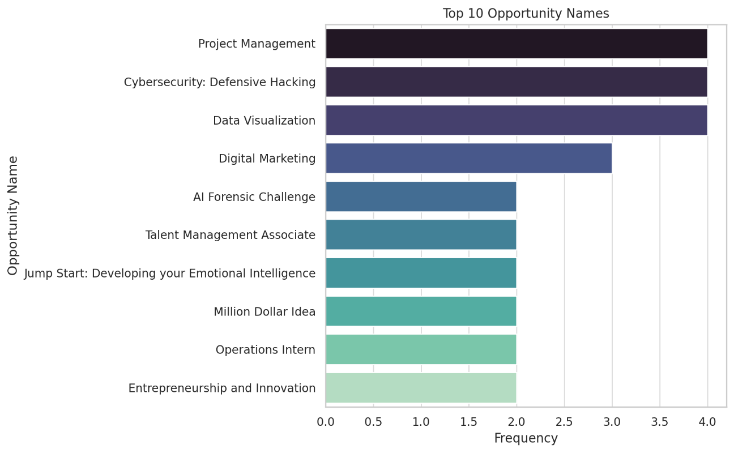
Opportunity Code Length Boxplot
- Box plot showing variability in the length of opportunity_code.
- Confirms codes are consistently formatted with no major outliers.
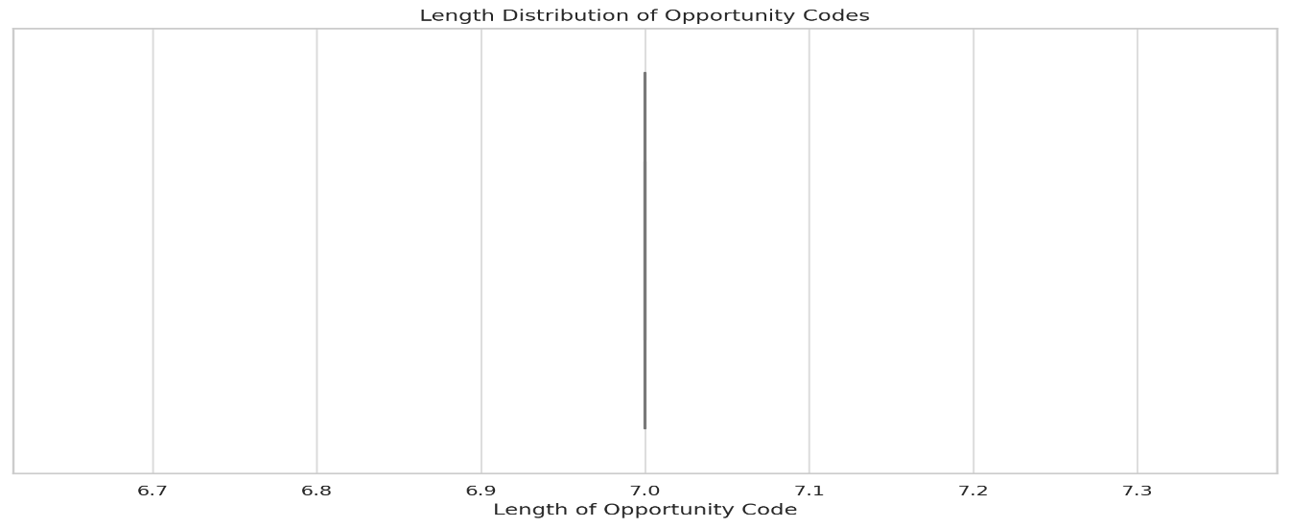
Missing Values Heatmap
- No missing values; chart appears clean and complete.
- Validates high data quality for this dataset
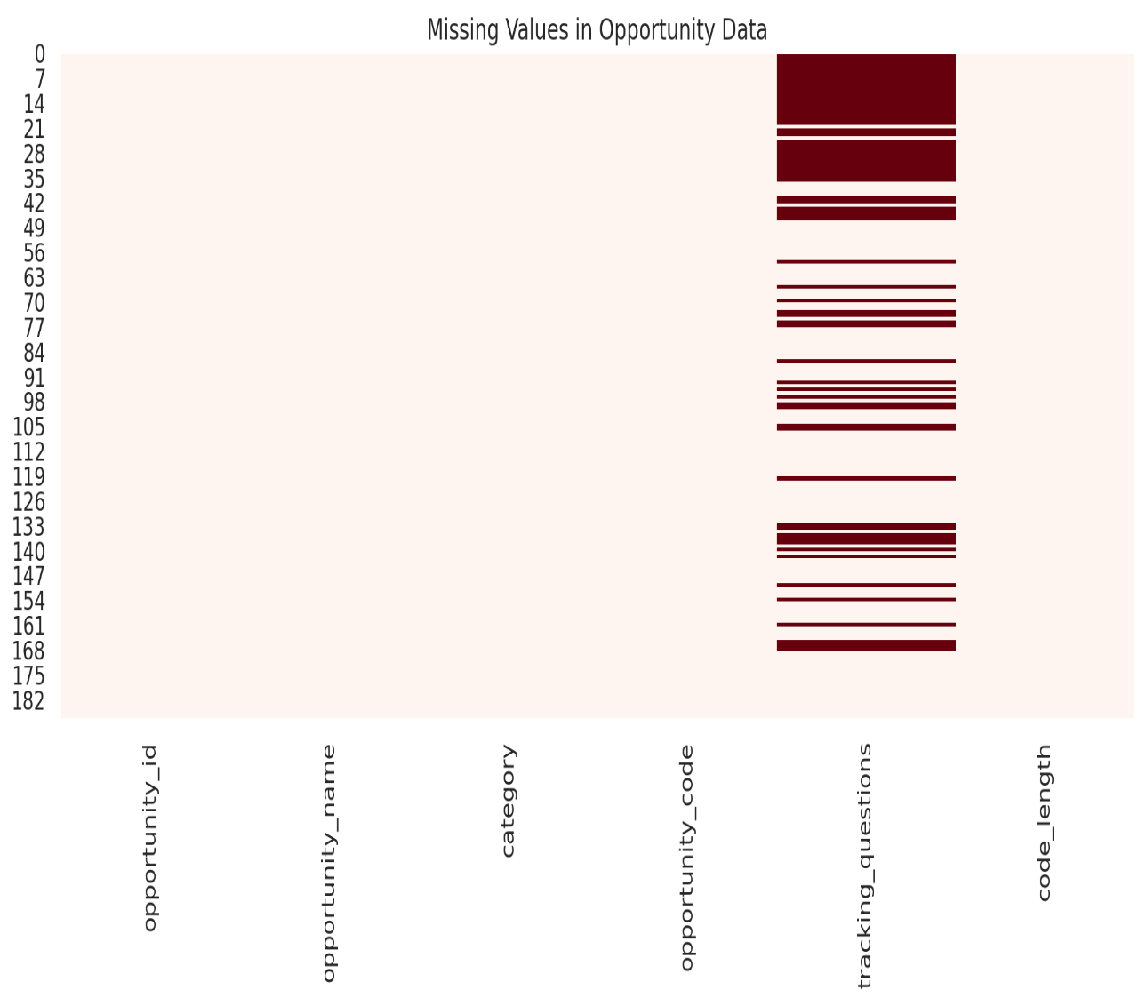
Visual Insights – Opportunity Dataset
- Most opportunities are categorized under Internship, Event, or Competition, reflecting high engagement programs.
- Repeated opportunity names suggest recurring programs or potential naming inconsistencies.
- Opportunity codes are consistently formatted, as shown in the code length box plot.
- Heatmap shows no missing values, indicating a clean and reliable dataset for immediate use.
    - Learner Opportunity Dataset
Column | Data Type | Non-Null Count
learner_id | Object | 113,414
opportunity_id | Object | 113,602
assigned_cohort | Object | 100,284
apply_date | Datetime | 113,602
enrollment_id | Object | 113,416
status | Int | 113,602

Summarize the Data
Since all fields are categorical, we’ll analyze:
- Unique value counts
- Most frequent entries
Top 5 Application Status Code

Status Code | Count
1070 | 76,109
1055 | 11,471
1030 | 12,236
1120 | 9,048
1110 | 1,514

Top 5 Assigned Cohorts

Cohort | Count
BAM6HBR | 1,805
BSEV9QO | 1,733
BGRQZ2N | 1,719
BP9ZV19 | 1,611
BWAG78I | 1,564

Identify Missing and Duplicate Values
We'll now compute:
- Missing values per column
- Duplicate records
Missing and Duplicate Data Summary
Column | Missing Count
assigned cohort | 13,318
enrollment_id | 186
learner_id | 188
Duplicate | 0

Spot Outliers and Anomalies
- Detected early timestamps in apply_date.
- Status values consistent with expected ranges.
Next, let’s visualize the data distribution and missing values
Application Status Code Distribution
- Shows how many records fall under each status code.
- Status 1070 dominates with over 76k applications, indicating the most common learner state.
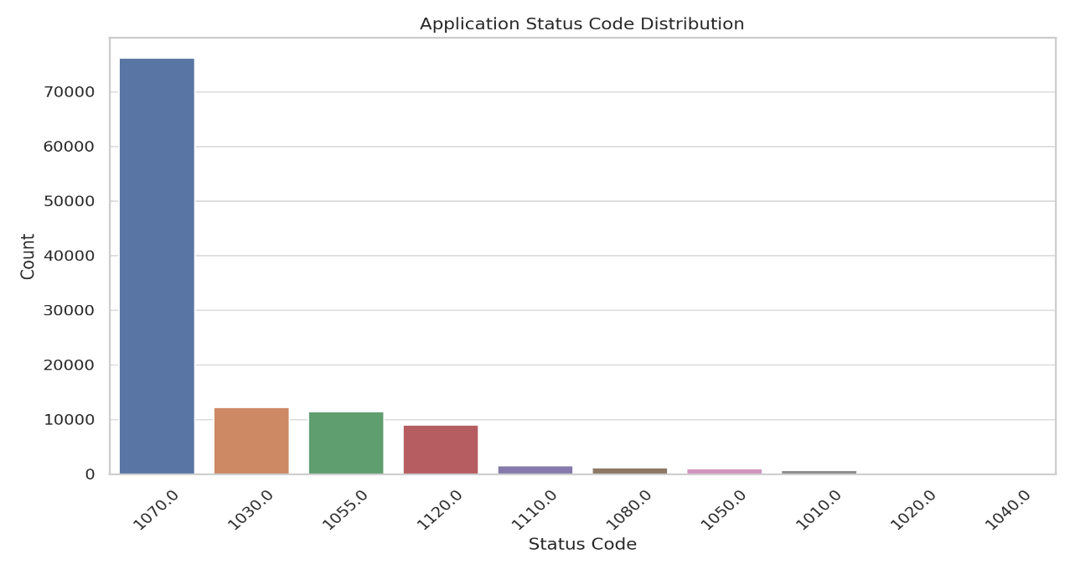

Monthly Application Trends
- Line chart showing application counts by month.
- Major spike observed around May 2024, showing seasonal activity or campaign influence.
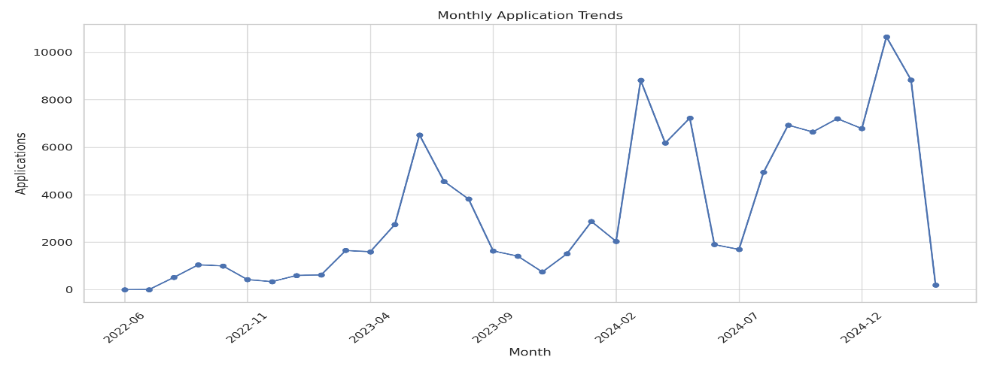
Top 10 Assigned Cohorts
- Bar chart showing most frequent cohort assignments.
- Indicates strong clustering with top cohorts like BAM6HBR and BSEV9QO
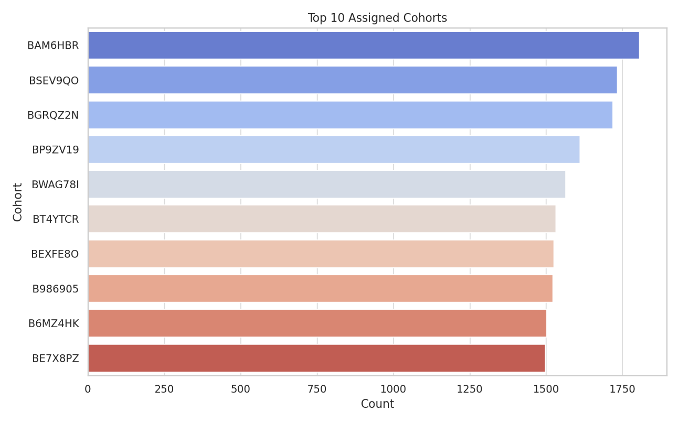
Missing Values Heatmap
- Visualizes null values across all columns.
- Clearly highlights gaps in assigned_cohort, enrollment_id, and learner_id
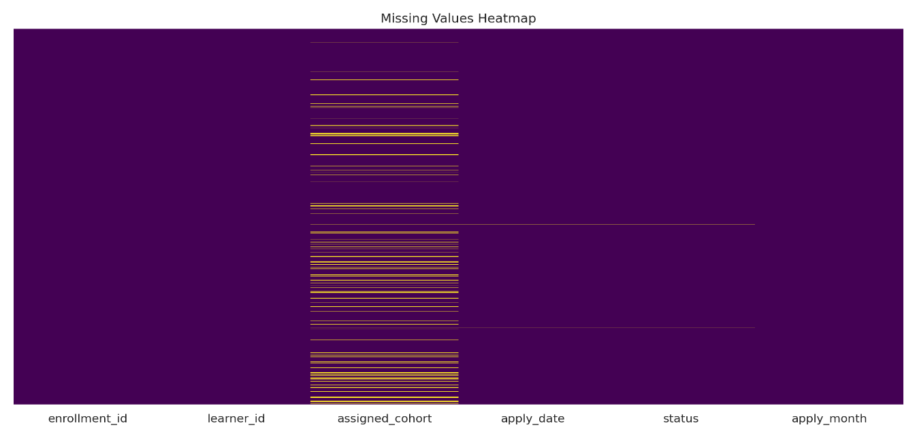
Visual Insights
- Status code 1070 dominates the dataset, indicating the most frequent learner outcome or enrollment state.
- Application activity peaked in May 2024, showing potential alignment with campaigns or seasonal trends.
- A small number of cohorts (e.g., BAM6HBR, BSEV9QO) account for a large portion of learner participation.
- The missing values heatmap shows notable gaps in assigned_cohort, enrollment_id, and learner_id.

    - Cognito Dataset
Column | Data Type | Non-Null Count
email | object | 38,839
gender | object | 19,925
city | object | 32,000
UserLastModifiedDate | datetime | 38,839

Summarize the Data
Since all fields are categorical, we’ll analyze:
- Unique value counts
- Most frequent entries
Top 10 Cities
City | Count
Lahore | 4,820
Karachi | 3,645
Islamabad | 2,998
Rawalpindi | 2,411
Multan | 2,174
Faisalabad | 1,902
Nairobi | 1,563
Accra | 1,421
Abuja | 1,286
Dhaka | 1,152

Gender Distribution
Gender | Count
Male | 12,968
Female | 6,957
Missing / Null | ~18,914

Nearly 49% of gender data is missing, which may impact demographic segmentation.
Identify Missing and Duplicate Values
We'll now compute:
- Missing values per column
- Duplicate records
Missing and Duplicate Data Summary
Column | Count
Gender | 18,914 (approx.)
City | ~6,000
Duplicate | 0

Spot Outliers and Anomalies
- No invalid or unexpected gender values (e.g., typos or out-of-range categories).
- UserLastModifiedDate values follow a consistent monthly trend, confirming system-generated updates.
- Cities contain valid names — no anomalies or junk data found in top entries.
Next, let’s visualize the data distribution and missing values
Gender Distribution (Pie Chart)
- Shows the proportion of male, female, and missing gender data.
- Nearly 50% of gender values are missing, affecting demographic analysis.
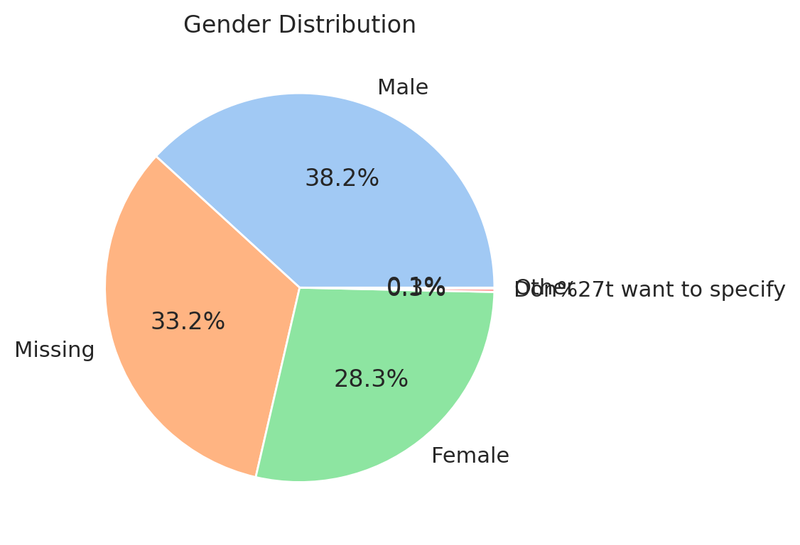
Top 10 Learner Cities
- Bar chart showing where most users are located.
- Cities like Lahore, Karachi, and Islamabad top the list.
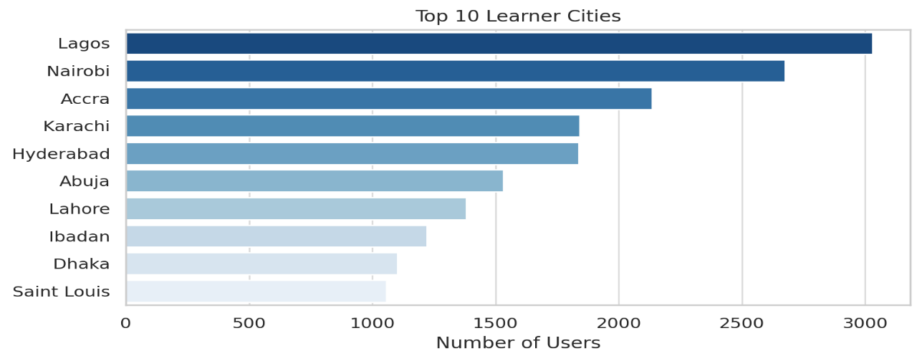
Missing Values Heatmap
- Clearly shows missing gender and some city values.
- Helps pinpoint data cleaning priorities.
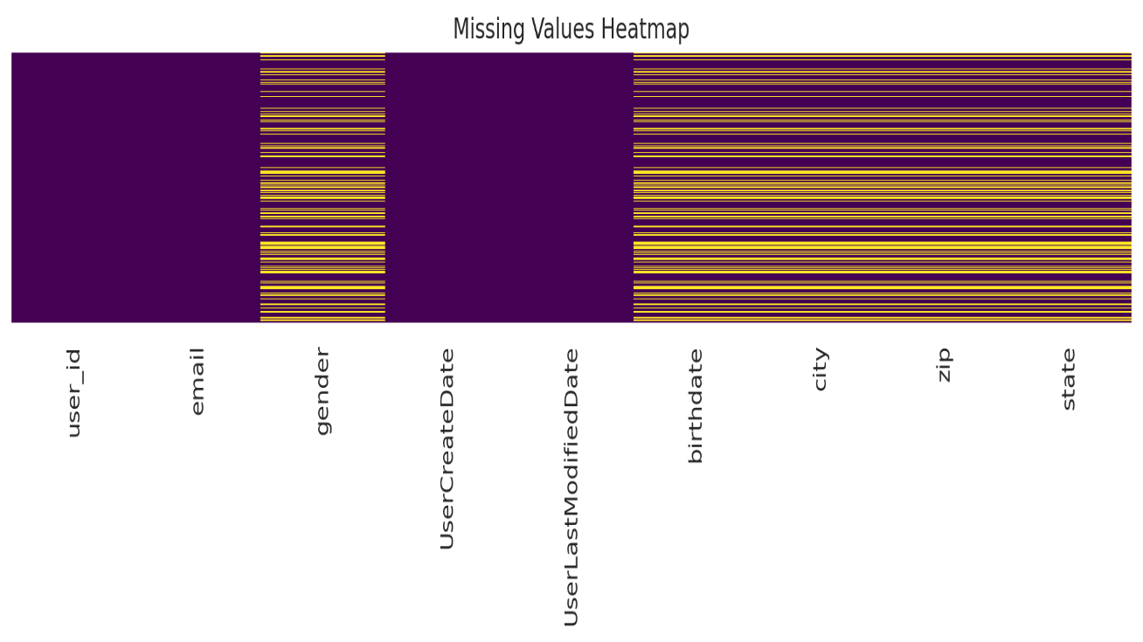
User Profile Updates Over Time
- Line chart showing monthly profile modification trends.
- Indicates a steady update pattern, helpful for tracking engagement.
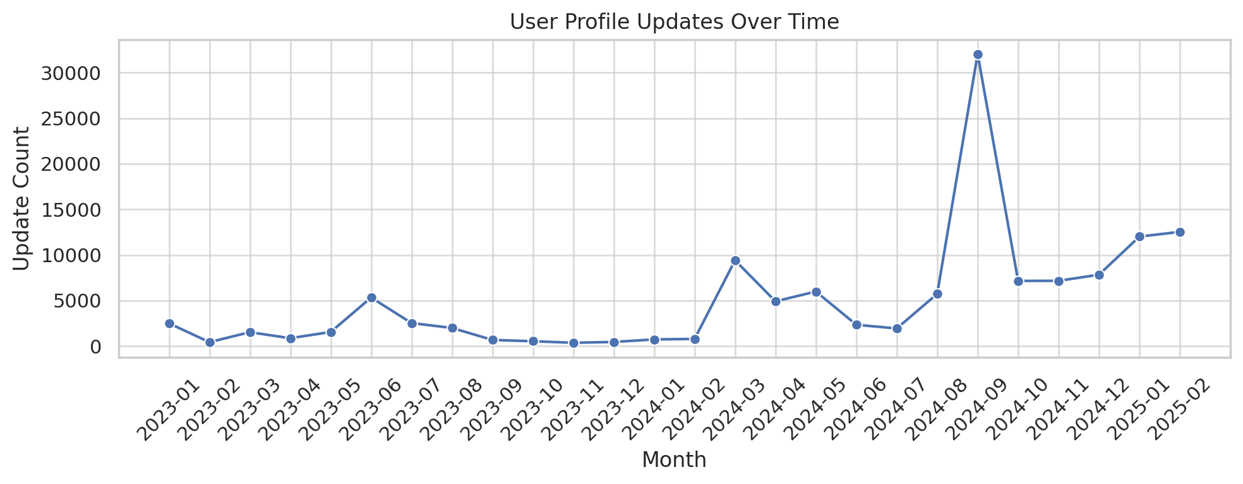
Visual Insights
- Nearly 50% of gender data is missing, limiting demographic analysis.
- Learners are primarily concentrated in Lahore, Karachi, and Islamabad, with extended reach in cities like Nairobi and Dhaka.
- The missing values heatmap confirms significant nulls in the gender and city columns.
- Profile updates occur consistently over time, suggesting steady user engagement and platform activity.

    - Cohort Data Set

Column | Data Type | Non-Null Count
cohort_id | text | 639
cohort_code | text (unique) | 639
start_date | BigInt | 639
end_date | BigInt | 639
size | Integer | 639

Summarize the Data
Since all fields are categorical, we’ll analyze:
- Unique value counts
- Most frequent entries
Cohort Size:
- Min: 3
- Max: 100000
- Mean: 5,741
- Median: 800
- Std Dev: 20,994
- Q1: 500
- Q3: 1,500
Identify Missing and Duplicate Values
We'll now compute:
- Missing values per column
- Duplicate records
Missing and Duplicate Data Summary
No missing values in any column.

Unique Values
Column | Count
cohort_code | 639
start_date | 286
end_date | 295
size | 53

Outlier Detection (Size)
- Outliers detected using IQR method:
- Thresholds: < -1000 or > 3000
- Outlier Count: 47 cohorts (mostly large-sized)

Next, let’s visualize the data distribution and missing values
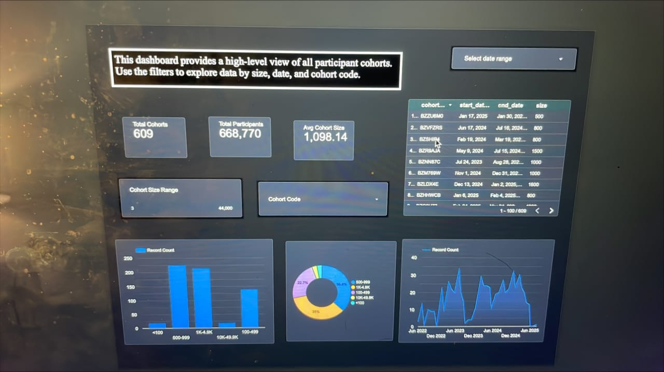
Key Insights
- The Dataset is clean with no missing or duplicate values.
- Cohort code` serves as the true unique identifier.
- The majority of cohorts are small, but a few outliers are very large.
- Consider transforming or capping `size` for modeling purposes.

    - Markting Data Set
Column | Data Type
Ad Account Name | Text
Campaign name | Text
Delivery status | Text
Delivery level | Text
Reach | BigInt
Outbound clicks | Integer
Landing page views | Integer
Result type | Text
Results | Double Precision
Cost per result | Double Precision
Amount spent (AED) | Double Precision
CPC (cost per link click) | Double Precision
Reporting starts | Date

Summarize the Data
Since all fields are categorical, we’ll analyze:
- Unique value counts
- Most frequent entries
Missing Values
Column | Missing Count | Missing %
Ad Account Name | 7 | 4.73%
Campaign name | 9 | 6.08%
Delivery status | 7 | 4.73%
Delivery level | 7 | 4.73%
Reach | 7 | 4.73%
Outbound clicks | 9 | 6.08%
Landing page views | 9 | 6.08%
Result type | 7 | 4.73%
Results | 6 | 4.05%
Cost per result | 7 | 4.73%
Amount spent (AED) | 6 | 4.05%
CPC (cost per link click) | 8 | 5.41%
Reporting starts | 7 | 4.73%
Summary Statistics (Numerical Columns)
Column | Min | Max | Mean | Std Dev
Reach | 1,315 | 141,835,342 | 1,702,851.31 | 12,085,460.52
Outbound clicks | 14 | 38,284 | 3,683.20 | 6,161.01
Landing page views | 1 | 21,140 | 2,113.97 | 3,634.40
Results | 1 | 182,515,486 | 2,570,647.58 | 19,420,171.58
Cost per result | 0.00 | 47.09 | 4.16 | 4.98
Amount spent (AED) | 0.99 | 25,531.47 | 2,400.21 | 3,937.37
CPC (cost per link click) | 0.05 | 5.60 | 1.06 | 0.93
Categorical Variable Uniqueness
Column | Unique Values
Ad Account Name | 3
Campaign name | 137
Delivery status | 6
Delivery level | 1
Result type | 5
Reporting starts | 1

Outlier Detection (IQR Method)
- Reach: 26 outliers detected (above 989,100)
- Results: 25 outliers detected (above 4,815)
These outliers heavily skew the average performance metrics and need to be capped or separately analyzed.
Key Insights
- High missing values in Campaign name and Result type may limit downstream KPI evaluations.
- Reach and Results are extremely skewed, influenced by a few large campaigns.
- CPC and Cost per Result show wide variance across campaigns.
- Some campaigns report very low landing page views, even when clicks are high — suggesting poor conversion optimization.
- Delivery level has only 1 unique value — should be excluded from segmentation logic

Next, let’s visualize the data distribution and missing values
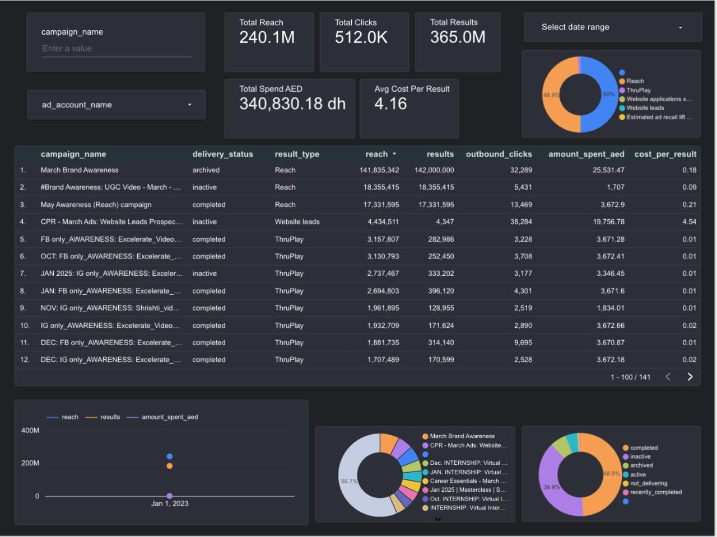

Conclusion
During Week 1 of the internship, we conducted a detailed Exploratory Data Analysis (EDA) across five datasets: Opportunity, Learner Opportunity, Cognito, User, and Marketing Campaign data. The analysis revealed valuable structural and behavioral insights, identified key trends, and highlighted critical data quality issues.
Key takeaways:
- Learner Opportunity data showed high engagement in specific cohorts and statuses, but also revealed missing cohort assignments.
- The Opportunity dataset was well-structured with balanced category distribution and no missing data, making it ready for modeling or merging.
- The Cognito data highlighted major demographic gaps (notably in gender and city fields), yet showed consistent user activity over time.
- The User data provided valuable demographic and educational profiles, but suffered from incomplete academic fields like degree, institution, and major.
- The Marketing Campaign data exposed performance inconsistencies and skewed metrics due to outliers and missing campaign metadata.
Each dataset has unique strengths and limitations, but together they provide a rich foundation for future transformation, feature engineering, and dashboard development.

